PROJECT DOCUMENTATION

CookBook: Your Virtual Kitchen Assistant.

1. Introduction
   * Project Title: CookBook: Your Virtual Kitchen Assistant.
   * Team ID: NM2025TMID30362
   * Team Leader: NANTHINI M – nanthinimathi543@gmail.com
   * Team Members:
   * NIRMALA S- nirmaladevinishanth@gmail.com
   * RAJESWARI V–rajeshwari2007r@gmail.com
   * PRIYADHARSHINI A–priyadharshini904313@gmail.com
2. Project Overview

Purpose:

"CookBook is your ultimate virtual kitchen assistant, designed to make cooking easier and more enjoyable. With a vast recipe library, meal planning tools, and step-by-step cooking guidance, you'll be whipping up delicious meals in no time. Whether you're a seasoned chef or a kitchen newbie, CookBook is here to help you cook with confidence. Get cooking and make every meal a masterpiece!"

Goals:

* + 1. Centralized Recipe Collection – Provide a digital platform to store and access recipes easily.
    2. Easy Navigation – Use a clean UI and React Router for smooth browsing between categories and recipe details.
    3. Learning Support – Integrate YouTube tutorials for step-by-step cooking guidance. iv. Category Organization – Group recipes by type (Beef, Chicken, Dessert, etc.) for quick discovery. v. User-Friendly Experience – Design an interface that is simple, responsive, and attractive.

vi. Reusable & Scalable – Build with React components so new features and recipes can be added easily.

Key Features:

* + 1. Recipe Categories – Browse recipes by popular food categories (Beef, Chicken, Dessert, etc.).
    2. Recipe Details Page – View ingredients, preparation steps, and video tutorials.
    3. YouTube Video Embedding – Watch cooking videos directly inside the app. iv. Search & Navigation – Quickly find specific recipes using smooth navigation. v. Responsive Design – Works on desktop, tablet, and mobile devices.

vi. Reusable Components – Built with React components for cards, lists, forms, etc. vii. API Integration (if added) – Fetch recipes dynamically using Axios.

viii. Modern UI – Styled with CSS and React Icons for a professional look.

1. Architecture

Component Structure

App.js — Root component, sets up routes and layout.

Navbar.jsx — Provides site navigation across pages (Home, Categories, Recipes).

Home.jsx — Homepage container, displays Hero, CategoriesHome, and NewsLetter.

CategoriesHome.jsx — Shows recipe categories on the homepage. Category.jsx — Page that lists recipes filtered by category.

Recipie.jsx — Page displaying a single recipe with details.

About.jsx — Static page about the Cookbook application.

Footer.jsx — Footer with branding, copyright, and links.

State Management

Local State: Managed using React useState and useEffect.

API Integration: Axios used for fetching data from CookBook API & YouTube API.

Library: react-router-dom Routes:

Routing

/ Home.jsx

/pages/Category => food Category.jsx

/category/Recipie ? Recipie.jsx

4. Setup Instructions

Prerequisites

Node.js & npm

Node.js is required to run React applications.

npm (Node Package Manager) is used to install dependencies. Download Node.js

React is the main JavaScript library used to build this project.

If you don’t have an existing React app, create one using:

npx create-react-app my-app cd my-app npm start

React.js

Git

Installation

In SB Fitzz, the React app is already created, so you just need to install dependencies (npm install).

Used for cloning and version control. Download Git

Code Editor

Recommended: Visual Studio Code (VS Code) Download VS Code

Basic Knowledge

HTML, CSS, JavaScript

React concepts (components, props, hooks, state, routing)

Get the code:

Download the code from the drive link given below:

https://drive.google.com/drive/folders/1u8PnV_mE0mwKkH_CvuNpliZtRLJZMqrO?usp=sharing Install Dependencies:

Navigate into the cloned repository directory and install libraries:

Navigate into the cloned repository directory and install libraries: cd CODE

npm install

Start the Development Server:

To start the development server, execute the following command:

npm start Access the App:

Open your web browser and navigate to http://localhost:3000.

You should see the application's homepage, indicating that the installation and setup were successful. Environment Variables Create a .env file with:

REACT_APP_API_URL=<https://exercisedb.p.rapidapi.com/exercises/equipmentList>

REACT_APP_YOUTUBE_API_KEY=<33cf3a7616msh4c3b1e3204f24e2p1294b3jsne16a7323d732> 5. Folder Structure

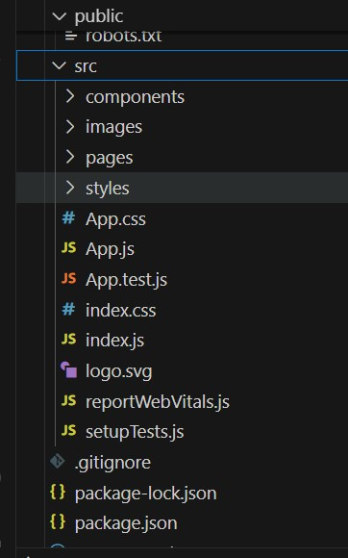

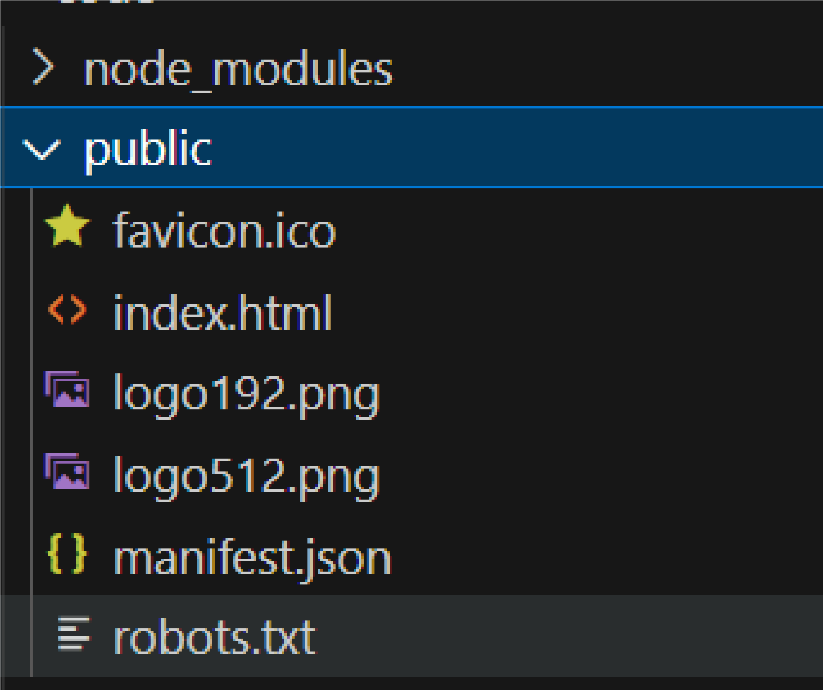

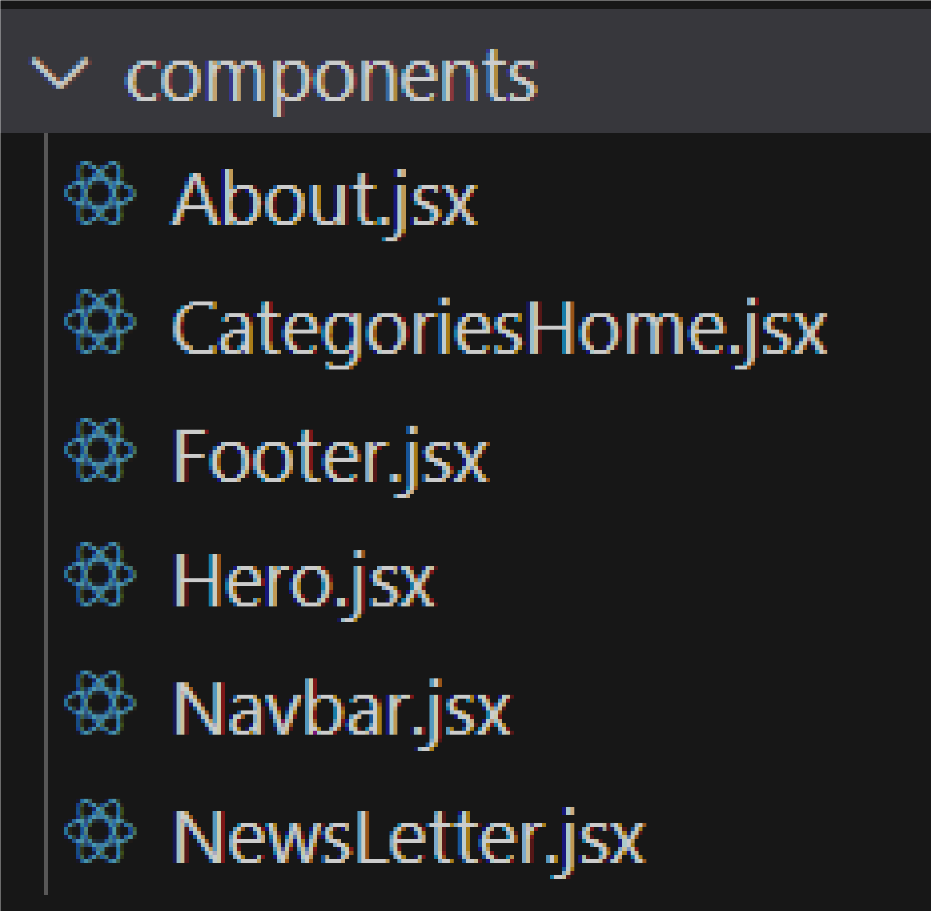

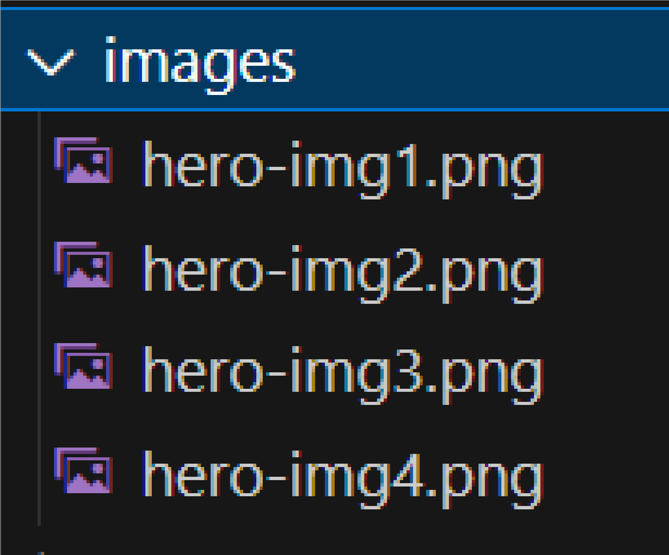

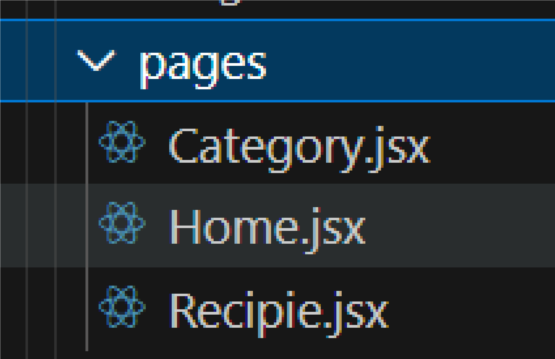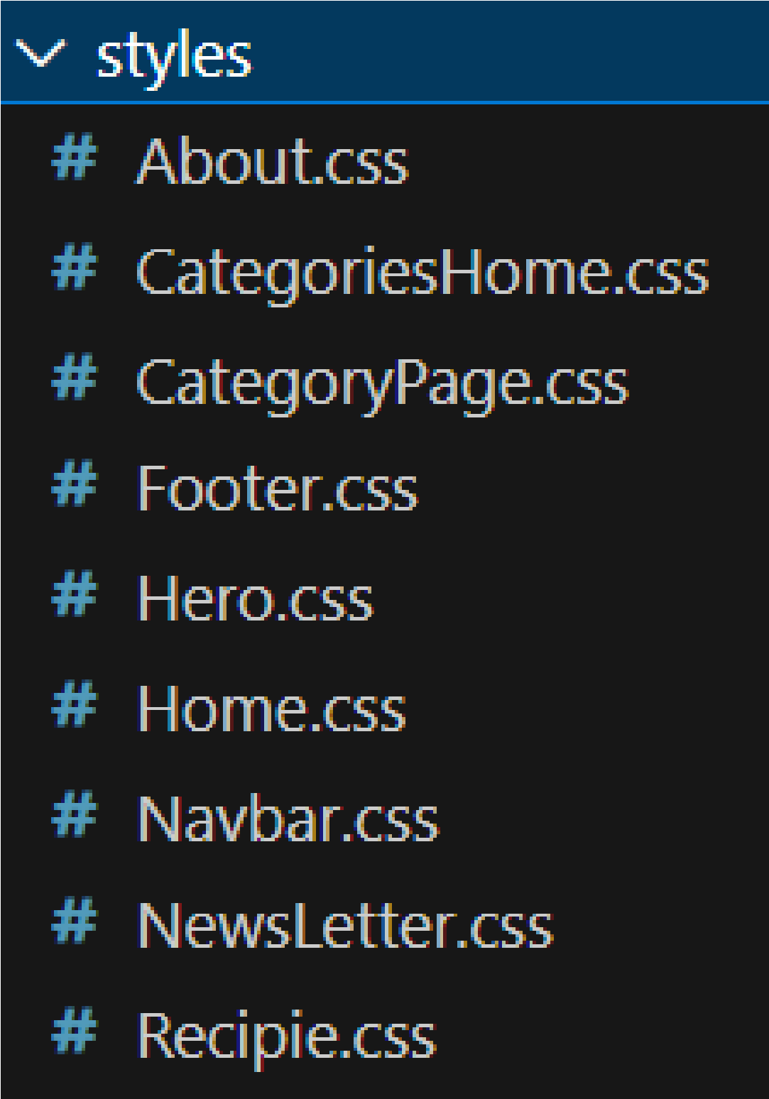



6.Running the Application

Start development server:

npm start

Build for production:

npm run build Run tests: npm test

1. Component Documentation

index.js => renders <App />

App.js => wraps Navbar, Routes, and Footer Home.jsx => (uses Hero, CategoriesHome, NewsLetter) category => Category.jsx (may also reuse CategoriesHome)

Recipie.jsx => (shows details of a recipe)Components import their CSS modules for styling.

images => used in Hero, Home, and Category pages

1. State Management

Local State:

Search queries stored in HomeSearch.

API data fetched and stored per-page.

Global State:

Not implemented — app uses component-level state.

9

. User Interface

Pages include:

Home (Hero + Search )

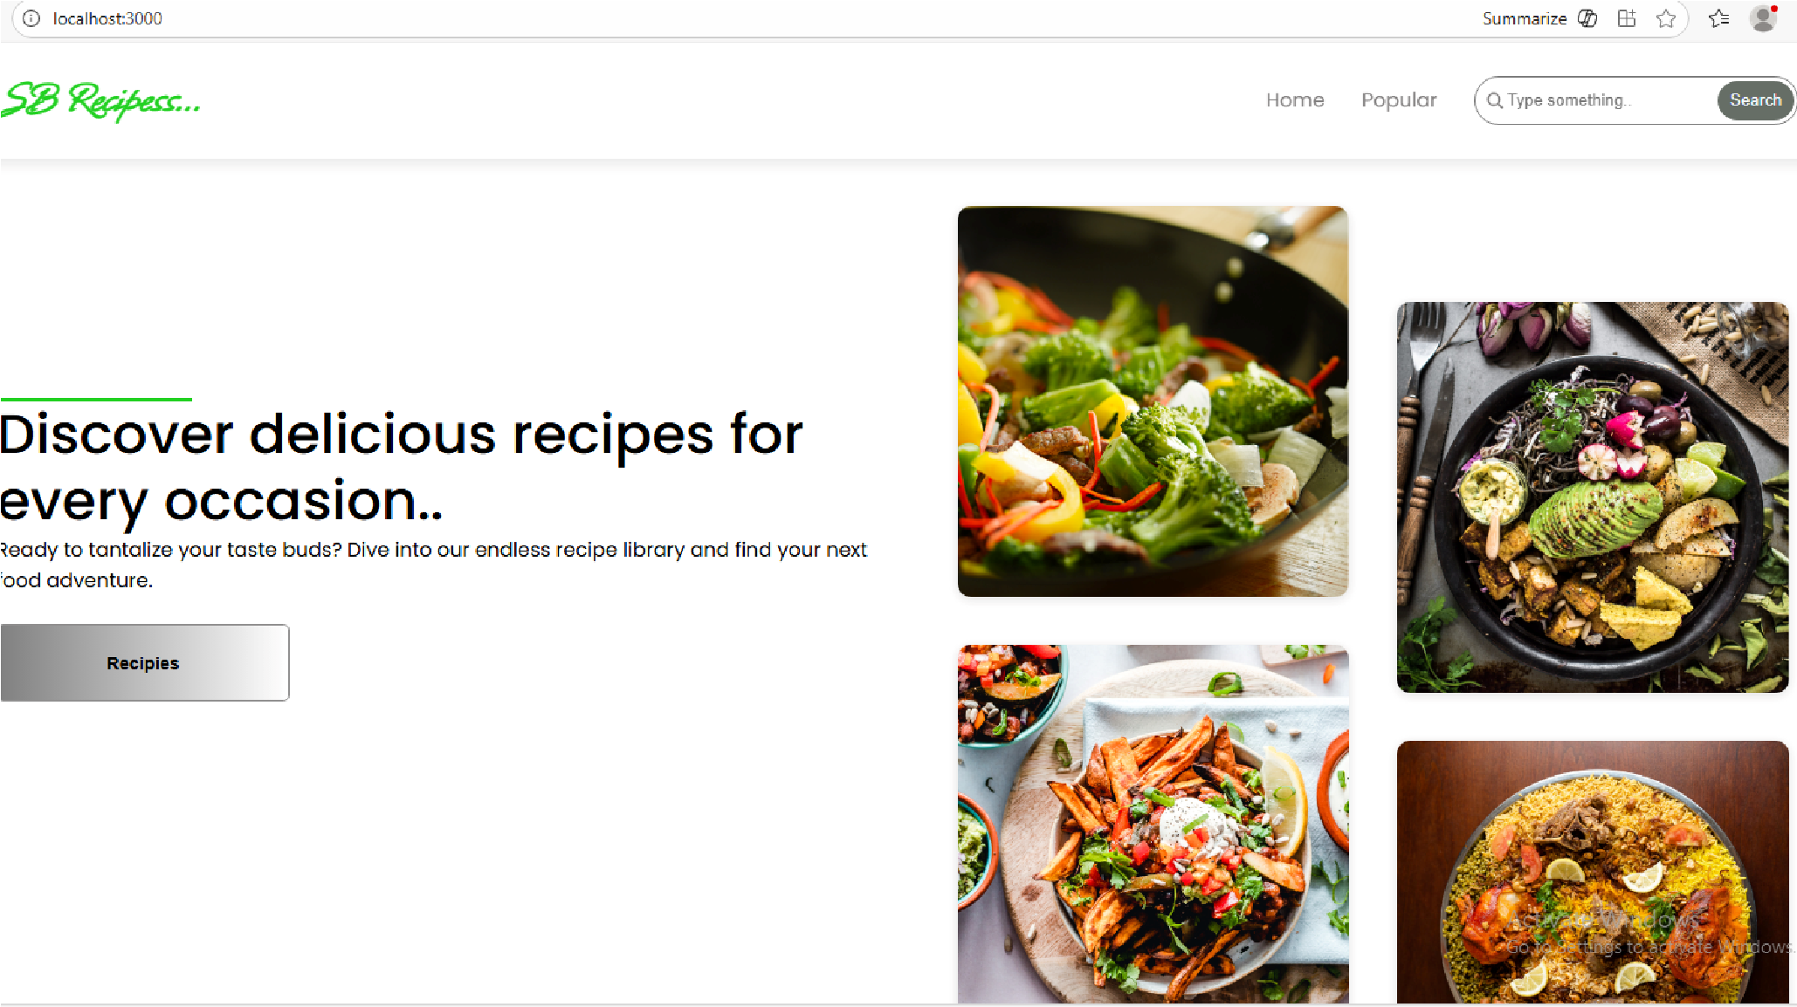

Popular:

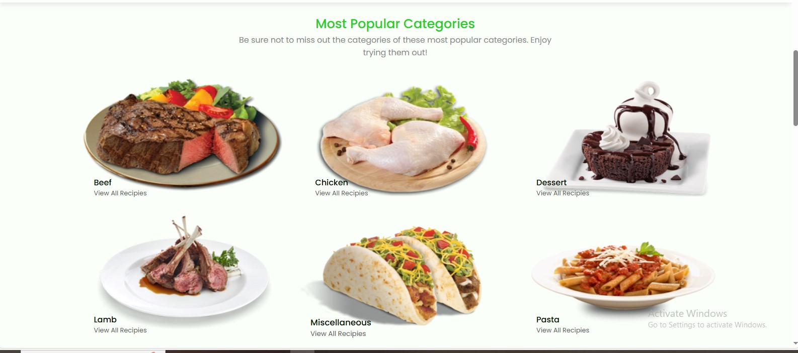

10

. Styling

Frameworks Used: Tailwind CSS / Bootstrap.

Custom CSS: Stored in src/styles/.

Each page/component has a dedicated CSS file for modularity.

11. Testing

Libraries Used: Jest, React Testing Library.

Unit Tests: Written in App.test.js.

Setup: Configured with setupTests.js.

API rate-limit may cause some exercises not to load.

YouTube API sometimes fails to fetch related videos.

14. Future Enhancements

12

. Screenshots / Demo

Demo Link:

WhatsApp Video 2025-09-08 at 5.11.46 PM.mp

[4](https://drive.google.com/file/d/1X1h8u4Y5ebqBiN2rjgiPK1mfhOpS61u3/view?usp=drive_link)

Screenshot:

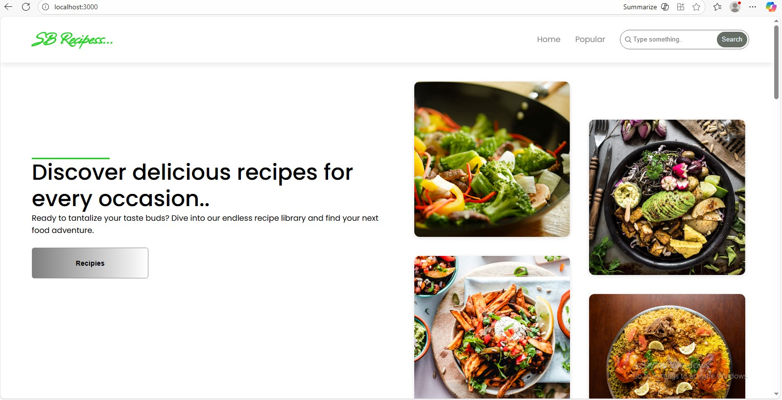

13

. Known Issues

User Authentication – Allow users to sign up, log in, and save their favorite recipes.

Recipe Submission – Let users add and share their own recipes with the community.

Search & Filters – Advanced search by ingredients, cuisine, prep time, or dietary needs.

Favorites & Collections – Users can bookmark recipes and organize them into collections.